Press Release
12 June, 2012
Energy-link between Africa and Europe
Morocco’s major energy event in 2012 with full institutional backing
The recent duty free agreement on industrial goods between Morocco and the EU, steady economic growth amounting to 4% and extensive governmental support in the renewable energy sector. All this makes Morocco a growth market concerning renewable and conventional energies. Morocco’s leading energy exhibition, the 7th elec expo, the 2nd EneR Event and the 1st Tronica Expo are scheduled to take place at the Casablanca International Fairgrounds – OFEC from 17 to 20 October 2012. This regional hub is organised by FENELEC, the Moroccan Federation of Electricity, Electronics and Renewable Energies, in close cooperation with the German trade fair specialists fairtrade and their Moroccan partners Forum 7.
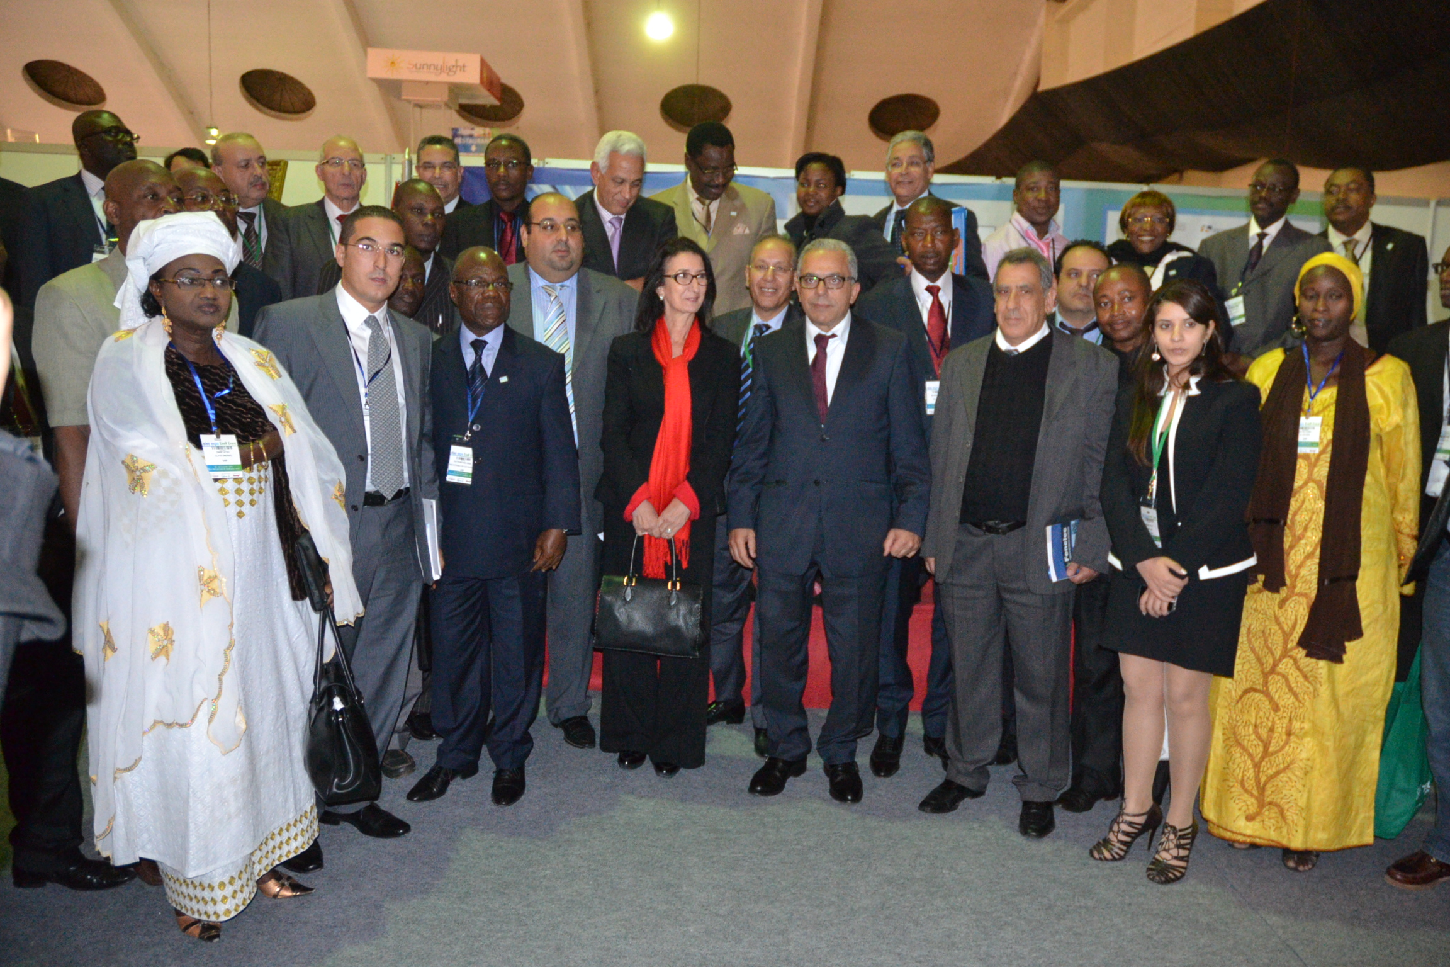
The importance of this exhibition for Morocco’s transition from an energy importer to an exporter is reflected by its full institutional backing. elec expo, EneR Event & Tronica Expo 2012 enjoy the official support of the Moroccan Ministry of Energy and Mines, Water and Environment, of the Ministry of Industry, Trade and New Technologies and of the lately created Ministry of Building, Urban Development and Regional Planning. As in 2011, the event benefits of a Hosted Buyers’ Program, which FENELEC will realise in cooperation with CAFELEC and Maroc Export, the governmental Moroccan Center for Export Promotion. A budget covering the expenses for travel and accommodation has been allocated to invite more than 50 African buyers of fourteen countries, both public and private buyers.
elec expo & EneR Event 2011: Participants of the Hosted Buyer's Program, Governmental Representatives and the Management of FENELEC and CAFELEC
Since 1 March 2012 the EU Association Agreement is fully implemented. This will cause a significant liberalisation in trading industry goods. Like this the Moroccan progress of reforms is rewarded by the international community. Imports of European industry goods to Morocco are duty free from now on (source: GTAI). In 2011, 5,246 registered trade visitors from 52 countries and 213 exhibitors (+88%) from 18 countries discussed business. FENELEC’s president Mr Youssef Tagmouti is quite confident to continue the success story of Morocco’s and Africa’s major energy, electrical engineering and electronics event in 2012.
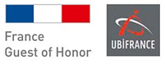
An increase of the above mentioned figures for this year’s edition is expected by the organisers, as France will be the Guest of Honor in 2012. “Without any doubt this event helps to further develop the economic and commercial ties between our two countries” underlines Henri Baissas, Deputy Director General and Director of Operations at UBIFRANCE, the French Trade Commission. Due to investments in the electro-technical sector amounting to one billion Euros, Morocco is one of the most important markets abroad for French companies, UBIFRANCE states on its website.
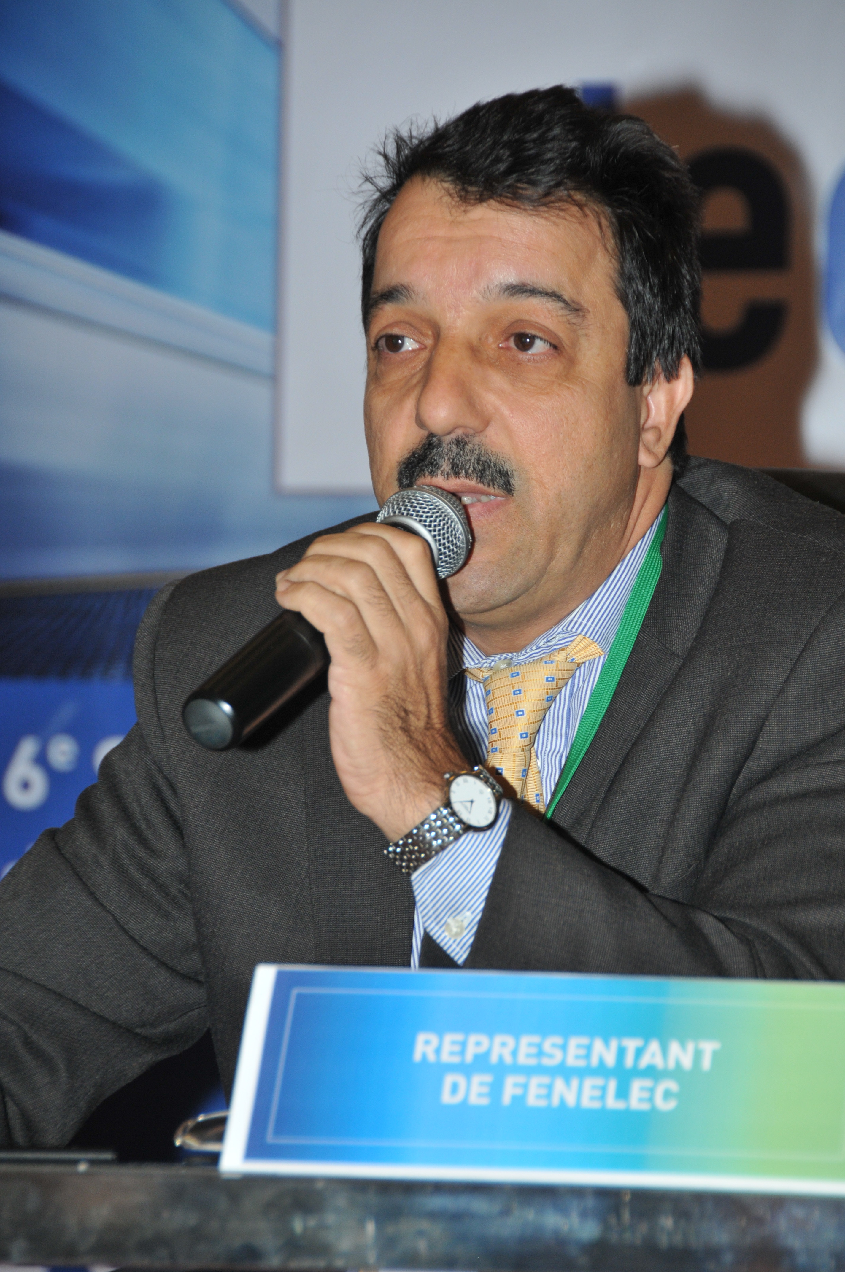
GTAI recently announced an increase of the German exports to Morocco amounting 10.7% in 2011. A major share of this is accounted for equipment for generating and distributing electricity, with an increase of 34% up to 111 million Euros. According to Martin Maerz, Managing Director with fairtrade, there still is huge potential in the field of renewables, benefitting from the climatic conditions, the extensive governmental support. Adds Ahmed Squalli, President of AMISOLE, the Moroccan Association for solar and wind industries: “Foreign companies should recognize the potential and take their opportunities to promote their products and ideas through a participation in this exhibition”.
Ahmed Squalli, President of AMISOLE, the Moroccan Association for solar and wind industries

www.elec-expo.com
www.ener-event.com
www.tronica-expo.com

About Fenelec:
Based in Casablanca, the National Federation of Electricity, Electronics and Renewable Energies today counts more than 400 member companies, representing more than 95 % of products and services in the Moroccan energy, electrical engineering and electronics’ sector. The staff of the member companies amount to more than 65.000. In 2011, the members’ annual turn-over exceeded 5 billion Euros.
About fairtrade:
Founded in 1991, fairtrade today is a leading organiser of highly professional international trade fairs in emerging markets. fairtrade has its headquarters in Heidelberg, Germany and maintains a powerful network of daughter companies, agencies and partnerships throughout the world. Being ISO 9001:2008 certified and a member of UFI The Global Association of the Exhibition Industry, fairtrade organises events according to the UFI quality norms.
About Forum 7:
Since 1987, the Casablanca-based agency Forum 7 has organised more than 80 events of major importance for Morocco and internationally, and is now the leading event organiser in Morocco – according to the Moroccan Association of Communication Agencies AACC. Forum 7 works within an international network of quality organisers.

Contact for press and media:  fairtrade GmbH & Co. KG  Dominik Rzepka  Head of Marketing & PR  Kurfuersten-Anlage 36  69115 Heidelberg, Germany  Tel +49 / 62 21 / 45 65 22  Fax +49 / 62 21 / 45 65 25  d.rzepka@fairtrade-messe.de  www.fairtrade-messe.de | Organiser:  FENELEC  4, Résidence Mervet,  Rue de la Bastille, Racine  20100 Casablanca, Morocco  Tel +212-522-94 51 29 / 94 91 82  Fax +212-522-94 96 42  fenelec@fenelec.com  www.fenelec.com
Delegate organiser:  fairtrade GmbH & Co. KG  Kim Wolters  Project Manager  Kurfuersten-Anlage 36  69115 Heidelberg, Germany  Tel +49-62 21-45 65-13  Fax +49-62 21-45 65-25  k.wolters@fairtrade-messe.de  www.fairtrade-messe.de | In close cooperation:  Forum 7  Zineb Sbata  Project Manager  5, Bd. Abdellatif Ben Kaddour  20 050 Casablanca, Morocco  Tel +212-522-94 59-71  Fax +212-522-36 06-21  zineb.sbata@agenceforum7.com  www.agenceforum7.com

