News Release # 26-12 | TSX Venture Exchange: PMV
 | Australian Securities Exchange: PVM
August 16, 2012 | Frankfurt: PN3N.F
THIS NEWS RELEASE IS NOT FOR DISTRIBUTION IN THE UNITED STATES OR TO U.S. NEWS AGENCIES

PMI Gold set to complete acquisition of Midras Mining Lease after receiving key Government approval

Strategic tenement adjacent to Obotan provides exploration upside and greater development flexibility

PMI Gold Corporation (TSX-V: PMV) (ASX: PVM) is pleased to advise that its 100%-owned subsidiary, Adansi Gold Company (Ghana) Limited (“Adansi”), will now proceed to complete the proposed acquisition of a highly strategic Datano Mining Lease located adjacent to its flagship Obotan Gold Project in south-west Ghana (Figure 1) after receiving Government approval for the transaction.

PMI announced last month that Adansi had entered into an agreement with Midras Mining Company Ltd (“Midras”) to acquire the Datano Mining Lease for US$6 million, subject to receiving approval for the sale and transfer of the mining lease to Adansi.

Adansi has now received formal notification from the Ghanaian Minister of Lands, Forestry and Mines, Hon. M. Hammah, that he has approved the assignment of the Datano-Manso Mining Lease from Midras to Adansi following a positive recommendation from the Ghana Minerals Commission.

This clears the way for the acquisition to be completed, with settlement now targeted for end of August.

PMI Gold’s Managing Director and CEO, Collin Ellison, said he was very pleased to have received approval from the Ghanaian Government for the assignment of the Datano Mining Lease, enabling it to complete the transaction with Midras.

“This in-fills a key gap in our tenement coverage at Obotan,” Mr Ellison said. “The 50km² Datano Mining Lease is contiguous with the southern boundary of the Obotan Project and lies to the south of the main Nkran deposit, providing us with access to the extensions of the mineralised Nkran and Fromenda structures and the opportunity to develop additional oxide resource targets close to Obotan.

“The lease area will also provide greater flexibility in the design of infrastructure within the Obotan Project Feasibility Study design, which is currently underway,” he added. “This puts another key element of the overall Obotan Project in place as we move towards completing the Feasibility Study in the coming weeks.”

On behalf of the Board,
"Collin Ellison"
Managing Director & CEO

For further information please contact:

Investor Relations Canada: Investor Relations Australia:
Rebecca Greco, Fig House Communications Nicholas Read/Paul Armstrong, Read Corporate

P. +1 (416) 822-6483 P. +61 8 9388 1474

E. fighouse@yahoo.com M. +61 419 929 046

PMI Contact Canada: PMI Contact Australia:
Marion McGrath, Corporate Secretary Collin Ellison, Managing Director & CEO

P. +1 (604) 684-6264 P. +61 8 6188 7900
Toll-Free: 1 (888) 682-8089

or visit the PMI Gold Corporation website at www.pmigoldcorp.com

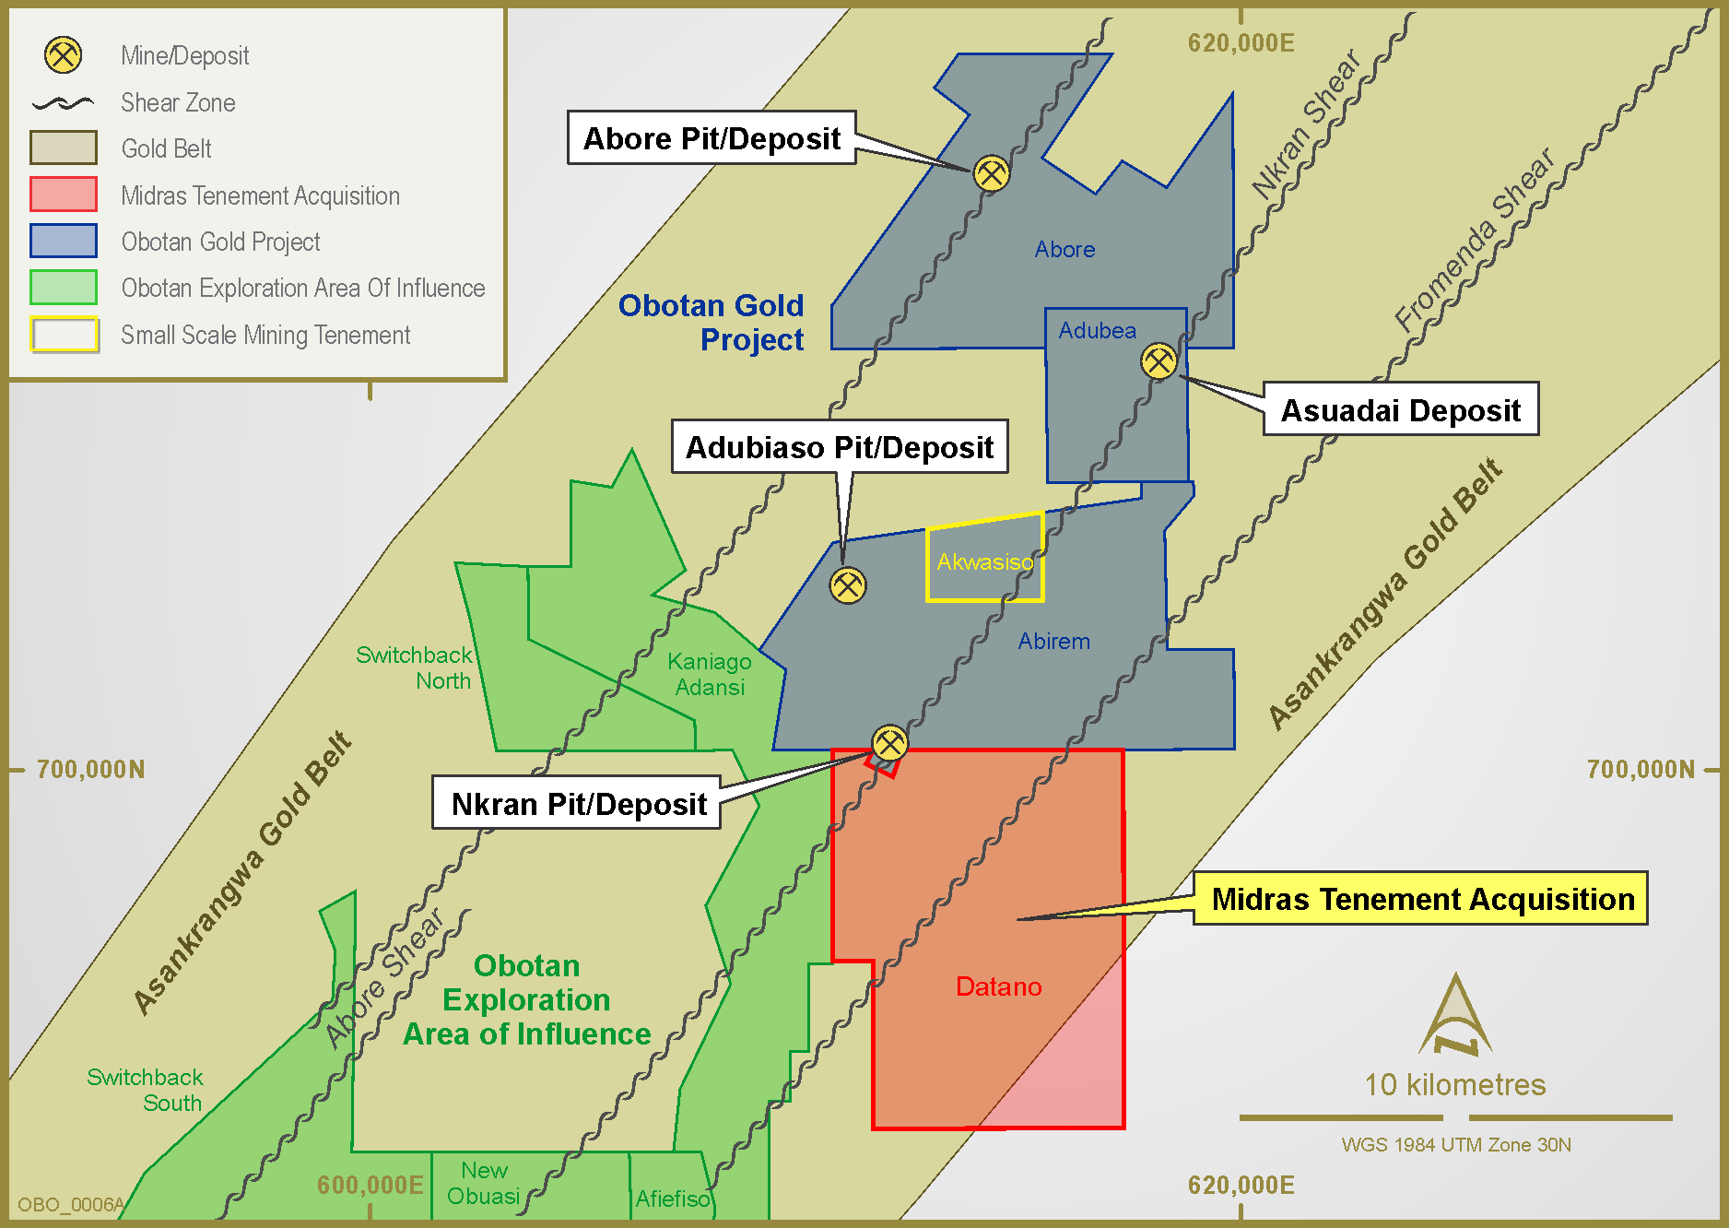
Figure 1: Location of Datano Mining Lease in proximity to PMI’s Obotan Gold Project

Neither the TSX Venture Exchange nor its Regulation Services Provider (as that term is defined in the policies of the TSX Venture Exchange) accepts responsibility for the adequacy or accuracy of this release.

