PROBE # 1679
This geothermal energy deposit is located near the Arad International Airport and it is an integrative part of the bigger geothermal energy deposit that lies between the Western side of Romania and Budapest, Hungary.
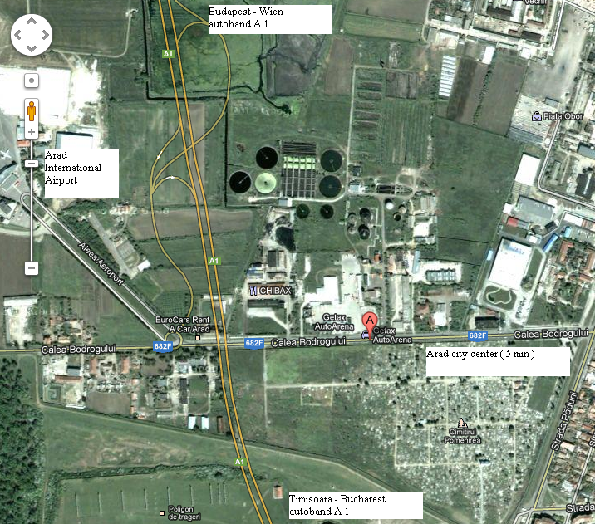
In 1982, the existence of Probe #1679 was noted as part of a national inventory program that had started in 1950. The aim of that program was to inventory and keep track of all natural resources within the country.

Probe #1679 is located on a private parcel of land. The land parcel size is 4347 m², with possibility to extended. TheIt is situated in an area with enormous development opportunities, very close to Downtown Arad, very close to the Arad International Airport and it has quick Interstate A1 access from westeern Europe
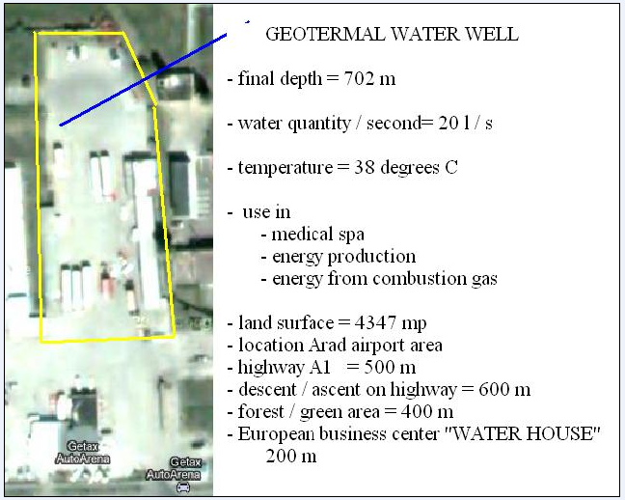
Probe #1679 is drilled to a depth of 702 meters and is built on columns measuring 9. 5/5/8/ centimeters down to a depths of 386 meters and on a column measuring 7 centimeters from 328 to 702 meters.

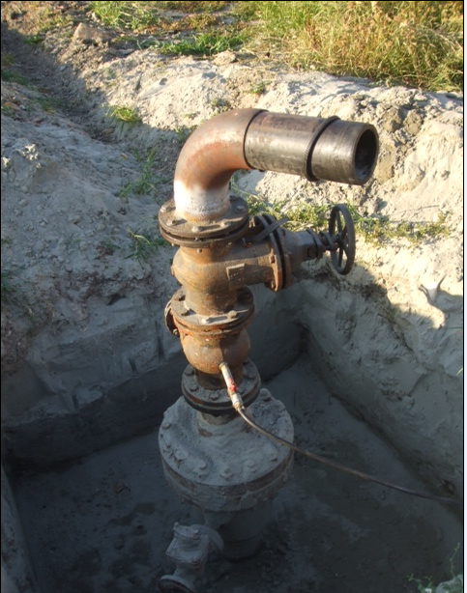

The flow probe is 20 liters/second, 72 cube meters/hour, 1728 cube meters/day, the mouth probe temperature is 38 degrees Celsius, and the heat quantity available is 1296 Gcal/h and 11352 Gcal/an

Given the composition and temperature of the geothermal water that comes from probe #1679, the water may be used, a very valuable resource, in various ways:
- As medical/health treatment, in a thermal water pool, thermal baths/spas, for people suffering of different health ailments such as rheumatoid arthritis, osteoarthritis, gout and allergies.
- As a viable heat source, given the high temperature of the water (as an added bonus additional heat pumps may be used and those can increase the final temperature by 8-10 degrees C).
- As a viable natural gas source (together with the water, the probe has an incredible quantity of nature gas and the gas can be captured and used as an energy source).
For this example, see photo here below:
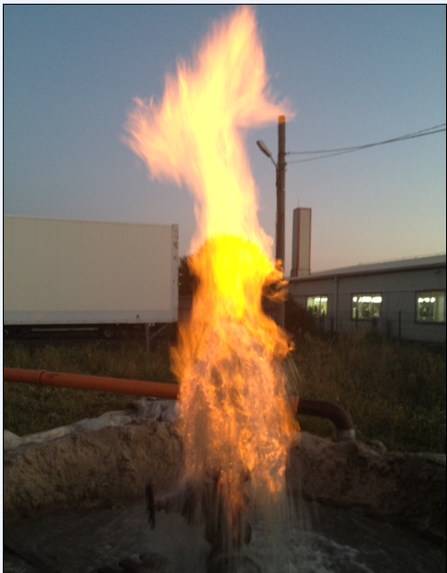
http://www.youtube.com/watch?v=RT_SCXc0wU0&feature=plcp

- As a more effective energy source; given the fact that this probe debits freely up to an undetermined height, the hydrostatic potential is endless, which means that the energy used in redirecting water pumps can be eliminated, thus saving a huge amount of energy. Instead, it can easily be accomplished through gravitational fall.

- As a health cure, through different chemicals and sand obtained in the water flow. The sand is extremely smooth and the chemicals have curative properties and both may be used as treatments.
For an illustration of this example, please take a look at this photo (sand and chemicals under a microscope):
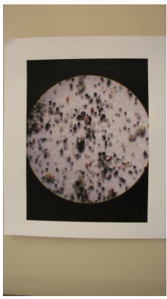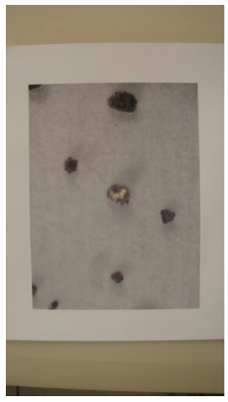

The benefits obtained from using Probe #1679 Arad are endless. The geothermal water is, in and of itself, an enormously valuable resource, but, when used synergistically, there are even more benefits. Also, the economic advantages (and savings) that come from using smart energy are incredible.
The best thing about type of energy is that it is renewable energy. This is, truly, intelligent energy.

