Deskbags can help children gain their educational independence

According to a recent report by UNESCO, there are as many as 95 million school children who do not have access to a school desk in Africa. In Southern Africa, the statistics are equally alarming, with over 4 million scholars requiring desks.

This is a statistic that doesn’t sit well with Madelain Roscher, Managing Director of PR Worx. “Education is one of the most important elements in a child’s life and while many children are eager to learn, their lack of facilities can considerably hamper their educational development and they subsequently struggle to become positive contributing members of society.”

Ideally, this issue could be solved by building more classrooms with relevant furniture, but due to the substantial investment required this is not an immediate solution. This is why PR Worx, an award winning public relations company, started up its own corporate social investment (CSI) division to manufacture DeskBags, to create a solution to the desk problem.

“Many children do not have access to formal classrooms, and they are forced to either kneel on the ground or work on make-shift desks during their school day, which as you can imagine is extremely uncomfortable. In addition, many of these children already carry a number of books and other supplies to school, and we didn’t want to add to their load. Moreover, we also didn’t want to encumber their journeys any further then they were already travelling, hence we created the DeskBag,” continues Roscher.

This unique tool for school going children not only offers children a durable school bag but also a portable desk solution. Besides for being waterproof, DeskBags are also eco-friendly as they are made from recycled vinyl billboard materials, with a durable Perspex flap which provides instant desk support when folded open.

PR Worx is certain that the introduction of Deskbags will help to create a more conducive environment for learning for many underprivileged children.

“In fact, we are so confident of the difference that DeskBags will make in the lives of underprivileged school children in South Africa that we are asking corporate companies to sponsor the bags, to help empower children in South Africa to flourish in their educational development,” says Roscher.

Deskbags are light enough for pre-primary scholars to use, and come with reflective binding that allow children to be easily spotted when walking in the rain or dark. These bags are also furthering employment opportunities for previously abused, disadvantaged or unemployed women, who are responsible for making them.

Ideally, Roscher would like to DeskBags grow to become a tool in every underprivileged school child’s educational development and in turn a part of a number of companies’ CSI initiatives.

She concludes, “We understand that the need for desks is too great a problem to tackle on our own but we also believe that DeskBags has the capability to change a nation by equipping tomorrow’s leaders today. We would therefore like to make a call to other corporate companies and government institutions to join us in our drive towards a better educated South Africa. It is as simply as providing a DeskBag to deskless child.”

For more information on how you can get involved with DeskBags, visit www.facebook.com/DeskBags.

/ends

Words: 537

High resolution photographs available on request:

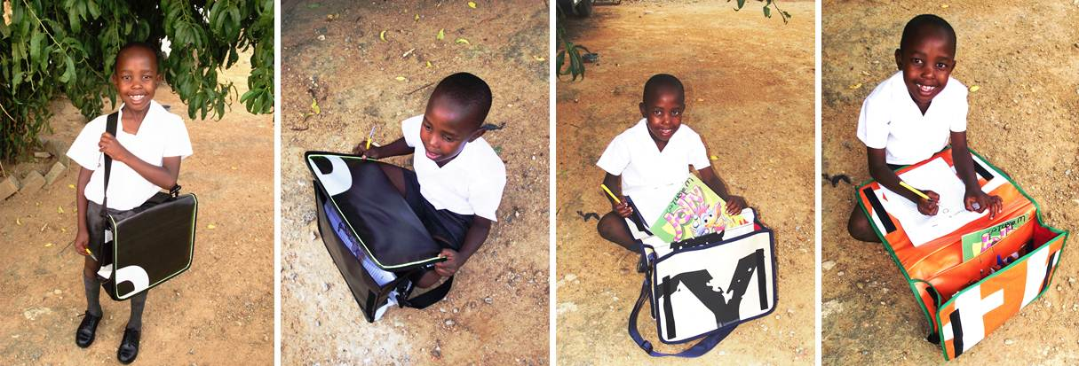
Katlego Motlogelwa demonstrating how DeskBags work

Issued by: Madelain Roscher
PR Worx
+27 11 896 1818 /+27 83 468 6819
madelain@prworx.co.za
www.prworx.co.za

