News Release # 22-12 | TSX Venture Exchange: PMV
 | Australian Securities Exchange: PVM
July 9, 2012 | Frankfurt: PN3N.F
THIS NEWS RELEASE IS NOT FOR DISTRIBUTION IN THE UNITED STATES OR TO U.S. NEWS AGENCIES

Agreement to Purchase Contiguous Mining Lease with the Obotan Gold Project

PMI Gold Corporation (TSX-V: PMV) (ASX: PVM) is pleased to announce that its 100% wholly-owned subsidiary, Adansi Gold Company (Ghana) Limited (“Adansi”) has entered into an agreement with Midras Mining Company Ltd (“Midras”) to acquire the Datano Mining Lease which sits contiguous to the Company’s flagship Obotan Gold Project in south-west Ghana (Figure 1).

The Midras concession covers an area of 50km² and sits strategically south of the Nkran deposit providing PMI access to the extensions of the mineralised Nkran and Fromenda structures and the opportunity to develop additional oxide resource targets close to the Obotan Project. The concession was previously explored by Ashanti Gold Corporation and Kiwi Goldfields Limited where multiple targets associated with traversing lineaments were recognised within a 7km wide corridor of the Asankrangwa Gold Belt.

The lease area will also provide greater flexibility in the design of infrastructure within the Obotan Project Feasibility Study design, which is currently in progress.

The agreement allows for a purchase price of US$6 million and is contingent upon obtaining the approval of the sale and transfer of the Mining Lease to Adansi by the Ghana Minerals Commission and Minister of Lands, Forestry and Mines.

On behalf of the Board,
"Collin Ellison"
Managing Director & CEO

For further information please contact:

Investor Relations Canada: Investor Relations Australia:
Rebecca Greco, Fig House Communications Nicholas Read/Paul Armstrong, Read Corporate
P. +1 (416) 822-6483 P. +61 8 9388 1474
E. fighouse@yahoo.com M. +61 419 929 046

PMI Contact Canada: PMI Contact Australia:
Marion McGrath, Corporate Secretary Collin Ellison, Managing Director & CEO
P. +1 (604) 684-6264 P. +61 8 6188 7900
Toll-Free: 1 (888) 682-8089
or visit the PMI Gold Corporation website at www.pmigoldcorp.com

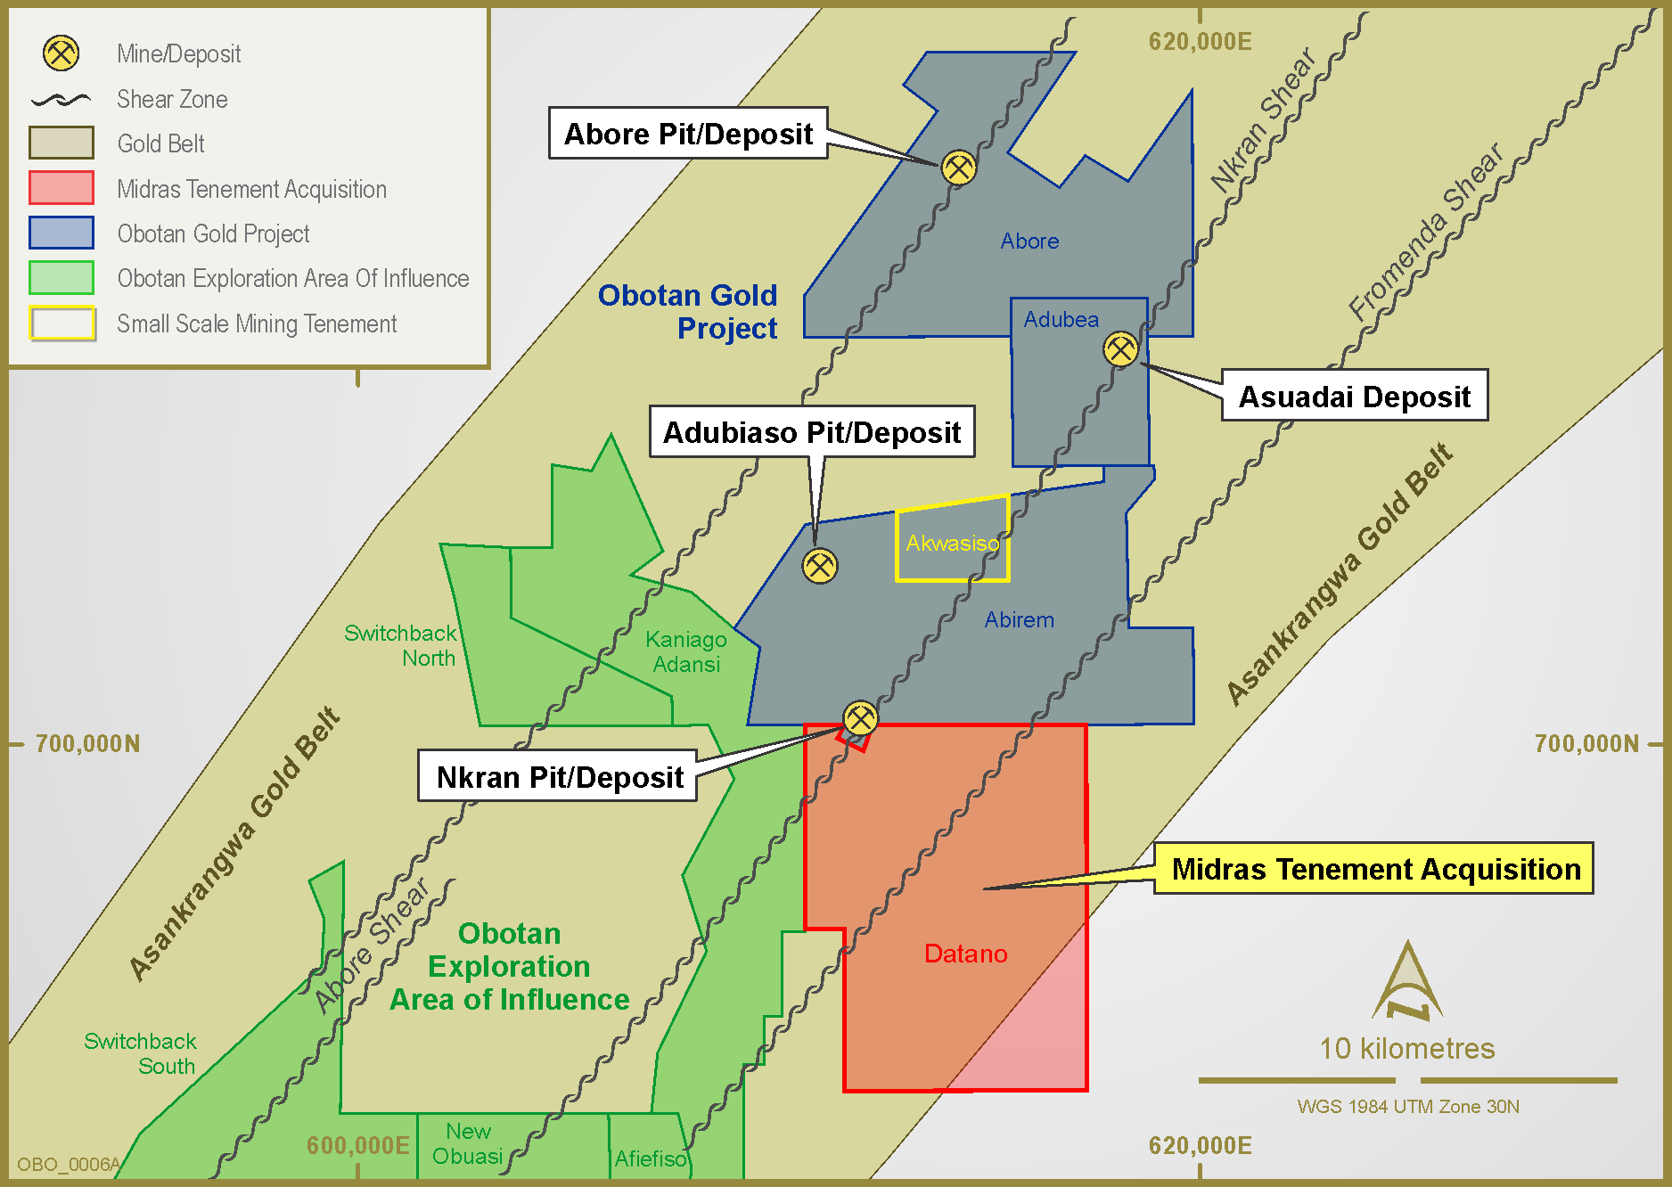
Figure 1: Location of Datano Mining Lease in proximity to PMI’s Obotan Gold Project

Neither the TSX Venture Exchange nor its Regulation Services Provider (as that term is defined in the policies of the TSX Venture Exchange) accepts responsibility for the adequacy or accuracy of this release.

