News Release # 28-12 | TSX Venture Exchange: PMV
 | Australian Securities Exchange: PVM
August 22, 2012 | Frankfurt: PN3N.F
THIS NEWS RELEASE IS NOT FOR DISTRIBUTION IN THE UNITED STATES OR TO U.S. NEWS AGENCIES

PMI Gold Corporation Announces Significant Drilling Intersections at its Kubi South Prospect

Key Points:
- Diamond drilling intersects significant gold mineralization at the Kubi South Prospect, located 1.5km south of the Kubi Main Deposit at PMI Gold’s Kubi Project within the Ashanti Gold Belt.
- The Kubi Project is located on the north-east trending Ashanti Shear Zone which hosts AngloGold Ashanti’s world-class Obuasi Gold Mine (pre-mined endowment of 60Moz) 15km to the north, and a series of cross-cutting east-northeast trending structures which coincide with Perseus Mining’s Edikan Gold Mine (6.6Moz) 12km to the south-west.
- A total of 12 diamond drill holes have been completed for 2,164.5m designed to follow up historical mineralized intercepts. All assay results have been received.
- Encouraging results include:
- 5m @ 3.33 g/t Au from 103m (including 2m @ 5.3 g/t Au from 103m)
- 8m @ 1.39 g/t Au from 116m (including 2m @2.56 g/t Au from 119m)
- 4m @ 1.55 g/t Au from 98m (including 1m @ 5.23 g/t Au from 101m)
- 2m @ 2.40 g/t Au from 120m (including 1m @ 4.1 g/t from 121m)
- Results confirm internal continuity and down dip extensions of mineralization beyond historical drilling, with mineralization open along strike to both the north and south.
PMI Gold Corporation (TSX-V: PMV) (ASX: PVM) is pleased to announce latest diamond drilling at the Kubi South Prospect (Figures 1-3), within PMI Gold’s 100% wholly-owned Kubi Project, has been completed and all assay results have been received. Drilling intersected multiple zones of significant gold mineralization ranging in strike length from 150m to 300m (Figure 4), open along strike to both the north and south, and also down dip.
The Kubi South Prospect is strategically located 1.5km south of the Kubi Main Deposit (NI43-101 and JORC Code compliant Mineral Resource estimate of Measured Resources of 0.66Mt @ 5.30g/t for 121,000oz, Indicated Resources of 0.66Mt @ 5.65g/t for 121,000oz, and Inferred Resources of 0.67Mt @ 5.31g/t for 115,000oz), both of which form along the highly prospective north-east trending Kubi Shear. The Kubi Shear forms the eastern boundary of the Ashanti Shear Zone which hosts AngloGold Ashanti’s world class Obuasi Gold Mine (pre-mined endowment of 60Moz), 15km to the north of the Kubi Project area.

Exploration by previous explorers at PMI Gold’s Kubi Project indicates that near-surface gold anomalism is extensively distributed along the Ashanti and Kubi Shears, both of which extend for the length of the project area. Deeper historical drilling has only been carried out at isolated locations and was principally focused at the Kubi Main Deposit. Several deeper drill holes have also been drilled into the Kubi South Prospect, with several significant mineralized intersections intercepted (refer to historical intercepts on Figure 4). A diamond drilling program was aimed at infilling these historical intercepts and testing the continuity of known mineralization along strike and down dip. Holes were drilled on a nominal 100m line spacing 25m apart. A total of 12 holes for 2,164.5m were drilled. All samples were sent to MinAnalytical Laboratory, Perth. Table 1 lists all significant intersections (>0.5g/t Au). Encouraging results include:
- KV12-540 5m @ 3.33 g/t Au from 103m (including 2m @ 5.3 g/t Au from 103m)
- KV12-546 2m @ 2.40 g/t Au from 120m (including 1m @ 4.1 g/t from 121m)
- KV12-549 8m @ 1.39 g/t Au from 116m (including 2m @2.56 g/t Au from 119m)
- KV12-551 4m @ 1.55 g/t Au from 98m (including 1m @ 5.23 g/t Au from 101m)
Mineralization is hosted within a 1m to 15m thick garnetiferous horizon within Birimian-age metasediments, near the contact with Tarkwaian-age metasedimentary rocks, which has been confirmed over a strike of 300m and is open both to the north and south and also down dip. The geological and structural setting of the Kubi South Prospect is identical to that at the Kubi Main Deposit. A series of east-northeast structures have also been identified from airborne and ground geophysical surveys. These structures coincide with Perseus Mining’s Edikan Gold Mine (6.6Moz), 12km to the southwest, and are considered favorable hosts for gold mineralization in Ghana.

The Kubi Project is the second project that PMI is currently developing in Ghana, along with the Obotan Project where the results of a Feasibility Study are due to be released in the September 2012 quarter. Drilling at the Kubi South Prospect formed part of PMI’s aggressive exploration push for the first half of 2012 which involved drilling over 85,000 metres at high priority targets within the Obotan, Kubi and Asanko Projects.

PMI Gold’s Managing Director and CEO, Mr Collin Ellison, said the results from the diamond drilling at the Kubi South Prospect highlight the potential for economic mineralization to be discovered within close trucking distance to the Kubi Main Deposit, adding to the known resource.

“Assays from the exploration drive from the first half of 2012 continue to come in, with some very encouraging numbers. The results from each of the prospects will be evaluated, with further follow-up drilling on high priority targets planned for the second half of 2012.”

On behalf of the Board,
"Collin Ellison"
Managing Director & CEO

For further information please contact:

Investor Relations Canada: Investor Relations Australia:
Rebecca Greco, Fig House Communications Nicholas Read/Paul Armstrong, Read Corporate

P. +1 (416) 822-6483 P. +61 8 9388 1474

E. fighouse@yahoo.com M. +61 419 929 046

PMI Contact Canada: PMI Contact Australia:
Marion McGrath, Corporate Secretary Collin Ellison, Managing Director & CEO

P. +1 (604) 684-6264 P. +61 8 6188 7900
Toll-Free: 1 (888) 682-8089

or visit the PMI Gold Corporation website at www.pmigoldcorp.com

Competent Person Statement

Exploration Results:

The information in this announcement that relates to Exploration Results is based on information compiled by Thomas Amoah, who is employed by Adansi Gold Company (Gh) Ltd, a wholly owned subsidiary of PMI Gold Corporation. Mr Amoah, who is a Member of the Australian Institute of Geoscientists (MAIG), has sufficient experience which is relevant to the style of mineralization and type of deposit under consideration and to the activity which he is undertaking to qualify as a Competent Person as defined in the 2004 Edition of the ‘Australasian Code for Reporting Exploration Results, Mineral Resources and Ore Reserves’. Mr Amoah consents to the inclusion in this report of the matters based on his information in the form and context in which it appears.

Scientific and technical information contained in this news release has been reviewed and approved by Thomas Amoah-n, MAIG, MSEG. a "qualified person" as defined under National Instrument 43-101. Field work was supervised by Mr Amoah (VP-Exploration). Drill cuttings were logged and sampled on site, with 3kg samples sent to the MinAnalytical prep laboratory on site, and analyzed for gold by fire assay-AA on a 50 gram sample charge or by screened metallics AA finish in MinAnalytical laboratory in Perth. Internal QC consisted of inserting both blanks and standards into the sample stream and multiple re-assays of selected anomalous samples. Where multiple assays were received for an interval, the final value reported was the screened metallic assay if available, or in lieu of that the average of the other results for the interval. Results from the QC program suggest that the reported results are accurate. Intercepts were calculated with a minimum 0.5 g/t Au cut off at the beginning and the end of the intercept and allowing for no more than three consecutive metres of less than 0.5 g/t Au internal dilution. True widths are estimated at from 60% to 70% of the stated core length.

Kubi Resource Estimate:

Information in this presentation that relates to Mineral Resources at the Kubi Main Deposit, Ghana, is based on a resource estimate that has been audited by Simon Meadows Smith, who is a full time employee of SEMS Exploration Services Ltd, Ghana. Simon Meadows Smith is a Member of the Institute of Materials, Minerals and Mining (IMO3), London and has sufficient experience which is relevant to the style of mineralisation and type of deposit under consideration and to the activity which he is undertaking to qualify as a Competent Person as defined in the 2004 Edition of the Australasian Code for Reporting of Exploration Results, Mineral Resources and Ore Reserves, and under NI43-101. Simon Meadows Smith consents to the inclusion in the presentation of the matters based on information in the form and context in which it appears.

Cautionary Note Regarding Forward-looking Statements

This news release includes certain forward-looking statements or information. All statements other than statements of historical fact included in this release, including, without limitation, statements relating to the potential mineralization and geological merits of the Obotan, Kubi and Asanko Projects and the plans, objectives or expectations of the Company with respect to the advancement of these projects and completion of scoping and pre-feasibility studies, are forward-looking statements that involve various risks and uncertainties. There can be no assurance that such statements will prove to be accurate and actual results and future events could differ materially from those anticipated in such statements. Important factors that could cause actual results to differ materially from the Company's plans or expectations include risks relating to the actual results of current exploration activities; fluctuating gold prices; possibility of equipment breakdowns, delays and availability; exploration cost overruns; availability of capital and financing; general economic, market or business conditions; regulatory changes; timeliness of government or regulatory approvals; and other risks detailed herein and from time to time in the filings made by the Company with securities regulators, including in the section entitled "Risk Factors" in the Company's Annual Information Form dated September 20, 2011. In particular, statements relating to the Company's plans to complete a feasibility study on the Obotan Gold Project by the end of June 2012 are subject to various factors, including positive results from ongoing exploration; expansion and upgrading of existing mineral resources; and completion of favourable geotechnical drilling programs, metallurgical test work, mine plan engineering, environmental and community relations assessments, and preliminary economic assessments. Due to the uncertainty which may attach to inferred mineral resources, it cannot be assumed that all or any part of the inferred mineral resources will be upgraded to indicated or measured mineral resources as a result of continued exploration. The Company expressly disclaims any intention or obligation to update or revise any forward-looking statements whether as a result of new information, future events or otherwise except as otherwise required by applicable securities legislation.

Neither the TSX Venture Exchange nor its Regulation Services Provider (as that term is defined in the policies of the TSX Venture Exchange) accepts responsibility for the adequacy or accuracy of this release.

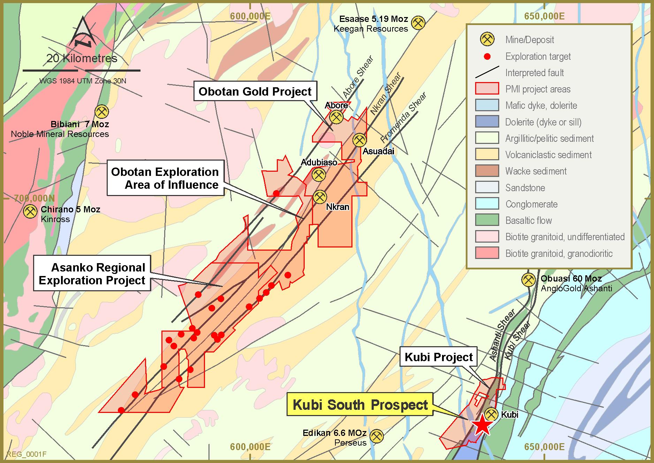

Figure 1: PMI Gold’s Project Location Plan showing Kubi Project

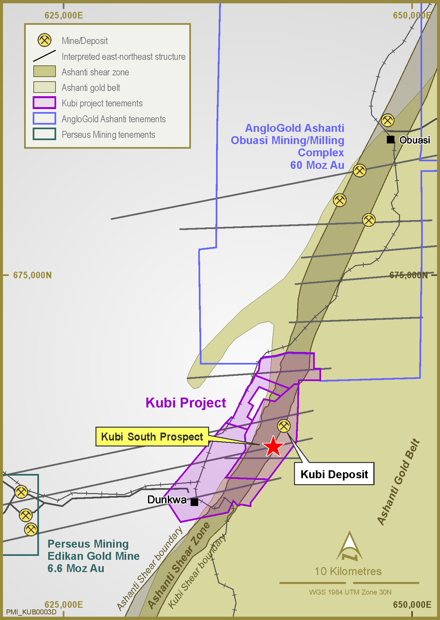
Figure 2: Kubi Project Tenement Plan showing Location of Kubi South Prospect

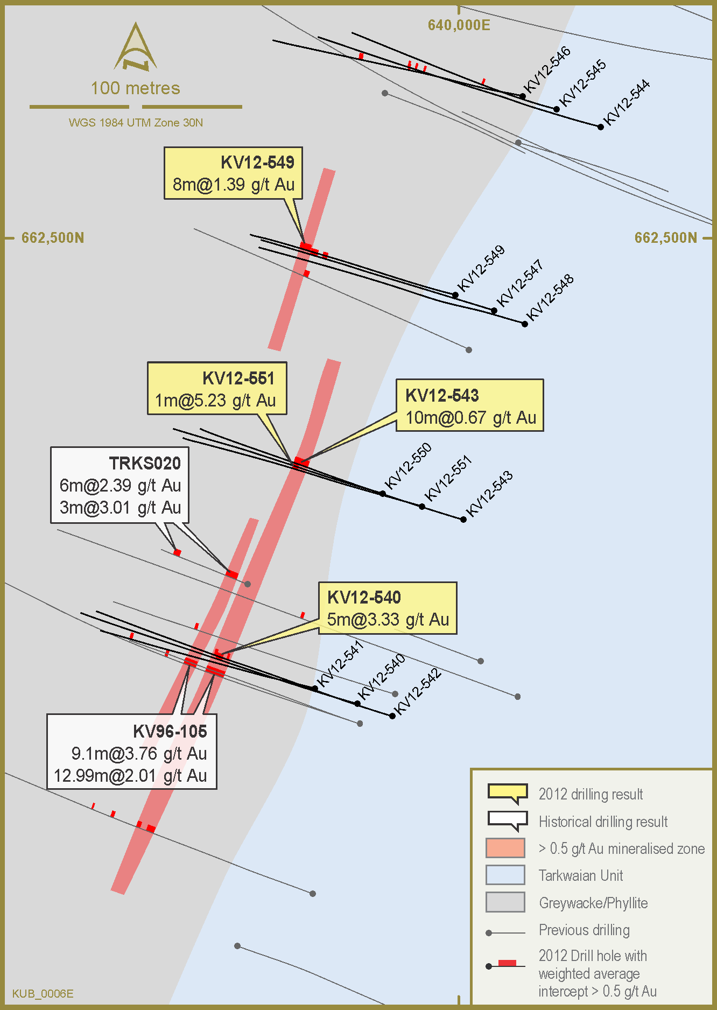
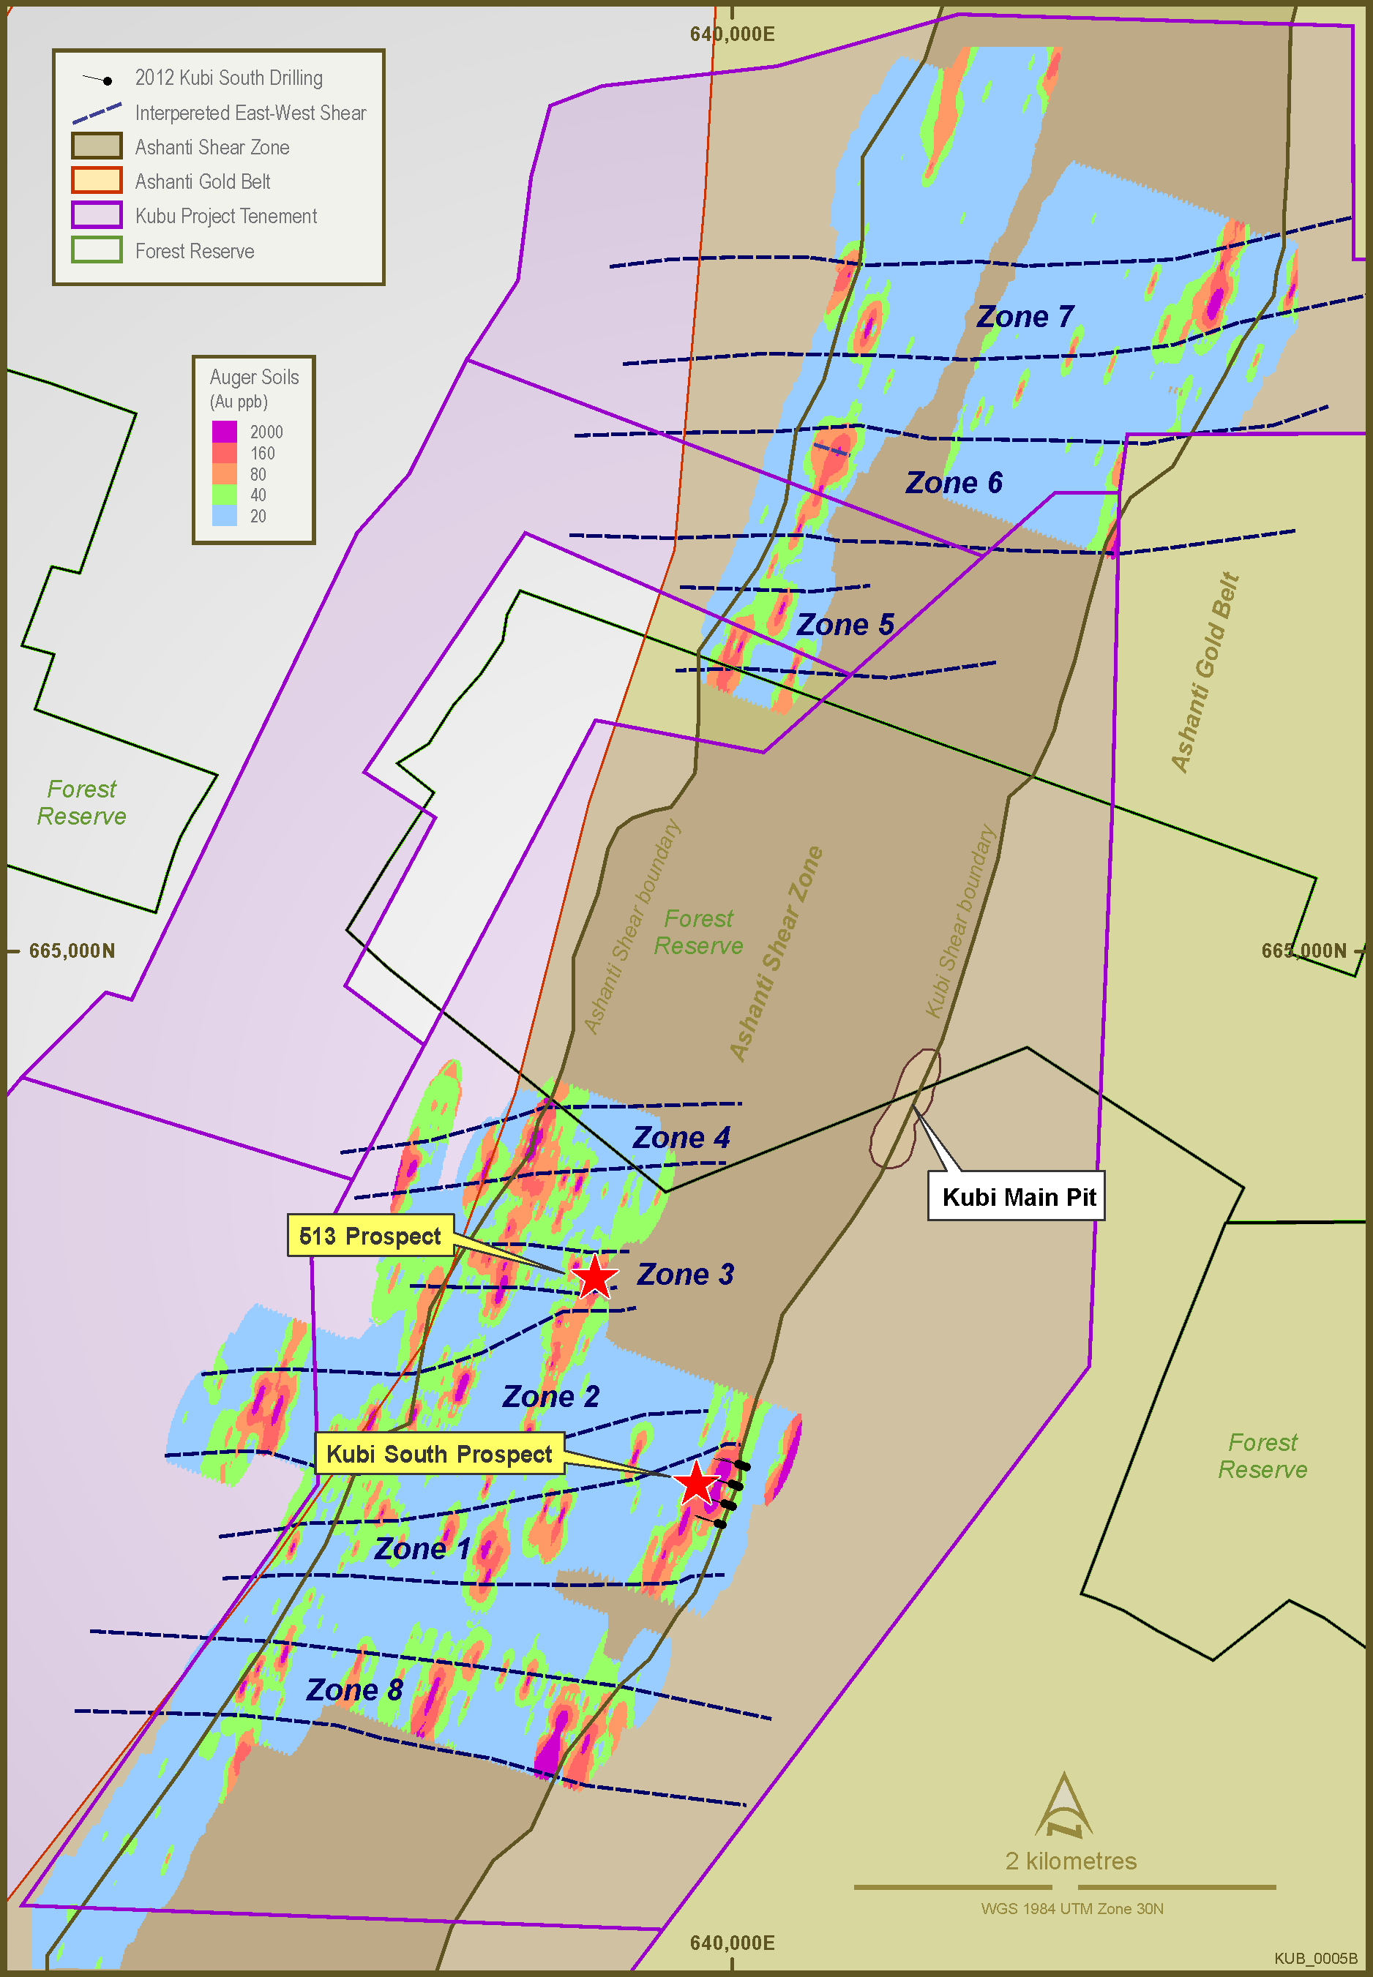

Figure 3: Gold Geochemical Anomalies from Auger Sampling Results, showing Kubi South Prospect Drilling Area
Figure 4: Drillhole Location Plan for Kubi South Prospect

Table 1: Significant Gold Intercepts (>0.5g/t Au)

Note : True widths are approximately 60% to 70% of the length of the stated intersection lengths.
Hole ID | Easting (UTM) | Northing (UTM) | RL (UTM) | Dip | Azimuth | Depth From (m) | Depth To (m) | Interval (m) | Weighted Avg. Grade (g/t)
KV12-540 | 639952 | 662280 | 132 | -50 | 290 | 103.0 | 108.0 | 5.0 | 3.33
including |  |  |  |  |  | 103.0 | 105.0 | 2.0 | 5.30
KV12-541 | 639932 | 662287 | 135 | -50 | 290 | 74.0 | 78.0 | 4.0 | 0.68
 |  |  |  |  |  | 138.0 | 140.0 | 2.0 | 1.00
KV12-542 | 639969 | 662274 | 130 | -50 | 290 | 128.0 | 129.0 | 1.0 | 1.51
 |  |  |  |  |  | 136.0 | 138.0 | 2.0 | 1.50
KV12-543 | 640002 | 662367 | 149 | -50 | 290 | 123.0 | 133.0 | 10.0 | 0.67
KV12-544 | 640067 | 662553 | 140 | -50 | 290 | 130.0 | 131.0 | 1.0 | 2.72
 |  |  |  |  |  | 136.0 | 137.0 | 1.0 | 1.96
KV12-545 | 640046 | 662561 | 147 | -50 | 290 | 59.0 | 60.0 | 1.0 | 1.38
KV12-546 | 640030 | 662567 | 149 | -50 | 290 | 120.0 | 122.0 | 2.0 | 2.42
including |  |  |  |  |  | 121.0 | 122.0 | 1.0 | 4.10
KV12-547 | 640017 | 662466 | 157 | -50 | 290 | 133.0 | 136.0 | 3.0 | 1.01
 |  |  |  |  |  | 140.0 | 142.0 | 2.0 | 0.64
KV12-548 | 640031 | 662460 | 152 | -50 | 290 | NSR
KV12-549 | 639998 | 662473 | 164 | -50 | 290 | 116.0 | 124.0 | 8.0 | 1.39
including |  |  |  |  |  | 119.0 | 121.0 | 2.0 | 2.56
KV12-550 | 639964 | 662380 | 162 | -50 | 290 | NSR
KV12-551 | 639983 | 662374 | 157 | -50 | 290 | 101.0 | 102.0 | 1.0 | 5.23

